Date: April-13-2025

**✅ Tasks Completed TodayL:**

* Created a Private repo on my Git as “**synthetix-ai-agent”**(just to begin with)
* Made a workflow just to have heads up with the tasks I need to work on.(my checklist)
* Started working on the main code or we can say agent.py file
* Created the Openai api key and made credentials for it.
* Everything was going good this far.

**🐞 Issues / Roadblocks:**

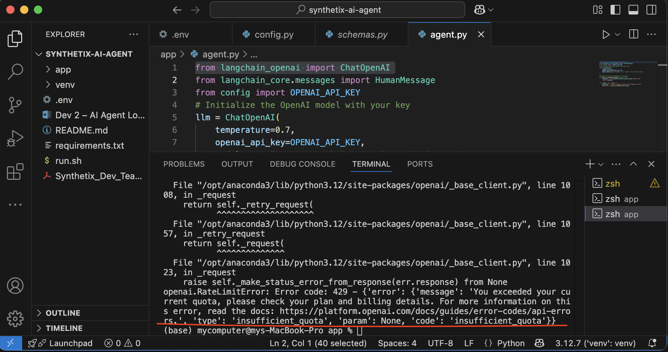

The Openai don't have enough credits; this means we need to buy credits to proceed with it. I looked into various options we can go for:

Option 1:

**Obviously getting into a plan paying for it to be used in our code**( I don't suggest this as we are building stage and investing into something like this at this stage would be foolish).

Option 2:

**Use a different provider temporarily**

We can switch to another model/provider temporarily. LangChain supports:

* Anthropic (Claude)
* Mistral
* Google Gemini
* Ollama (local)
* OpenRouter.ai (works with various models, including GPT)

Option 3:

**Use FakeLLM or mock LLM for local dev**( I used this just to check my logic its working so far but this is not the aim we want to make agent specific model)

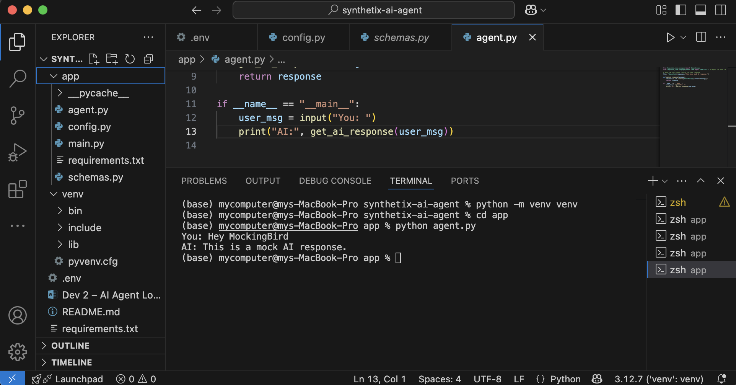

**🧠 Learnings / Insights:**

* Understood the deprecation of ChatOpenAI from langchain core and learned how to migrate to the langchain-openai package.
* Gained familiarity with how to use .invoke() instead of the deprecated .predict() method in newer versions of LangChain.
* Learned how to mock the LLM response to bypass quota errors during development.
* Realized the importance of version compatibility and monitoring package updates in LangChain and OpenAI SDKs.

**📌 To-Do for Tomorrow:**

* Replace actual LLM with efficient local or free alternative
* Abstract AI agent logic for easier swap of LLM backend (OpenAI → local).
* Research and list 2–3 free or open-source LLMs for possible integration